**DAILY ONLINE ACTIVITIES SUMMARY**

|  |  |  |  |  |  |  |  |
| --- | --- | --- | --- | --- | --- | --- | --- |
| **Date:** | **18/05/2020** | | | | **Name:** | **JYOTHI LAKSHMI** | |
| **Sem & Sec** | **8th sem, A sec** | | | | **USN:** | **4AL16CS129** | |
| **Online Test Summary** | | | | | | | |
| **Subject** | | **SMS** | | | | | |
| **Max. Marks** | | **60** | | **Score** | | **19** | |
| **Certification Course Summary** | | | | | | | |
| **Course** | **JAVA PROGRAMMING(240 mins)** | | | | | | |
| **Certificate Provider** | | | **Great Learning** | **Duration** | | | **24 mins** |
| **Coding Challenges** | | | | | | | |
| **Problem Statement: 1) To print the frequency of each character in a string. 2) Java program** | | | | | | | |
| **Status: Completed** | | | | | | | |
| **Uploaded the report in Github** | | | | **Yes** | | | |
| **If yes Repository name** | | | |  | | | |
| **Uploaded the report in slack** | | | | **Yes** | | | |

Online Test Details:

Online examination is conducting a test online to measure the knowledge of the participants on a given topic. With online examination students can do the exam online. The test was on the subject System Modeling and Simulation under the topic Random numbers generation technique.

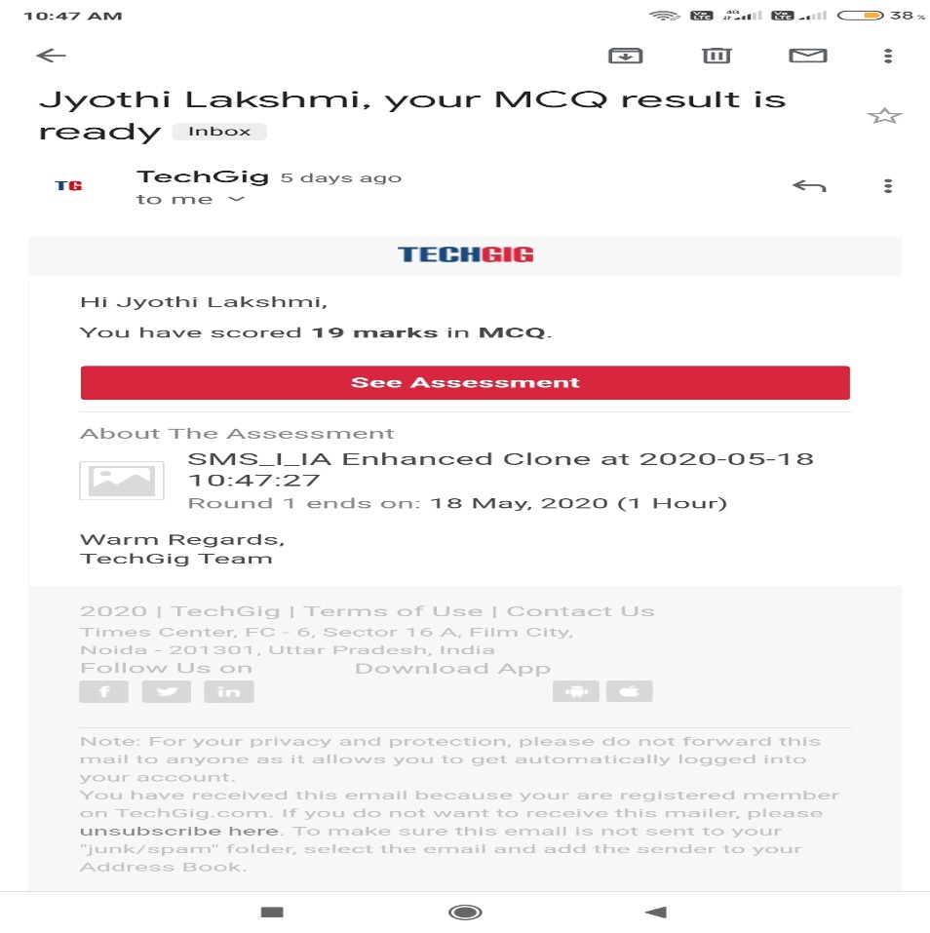

ONLINE CERTIFICATION COURSE:

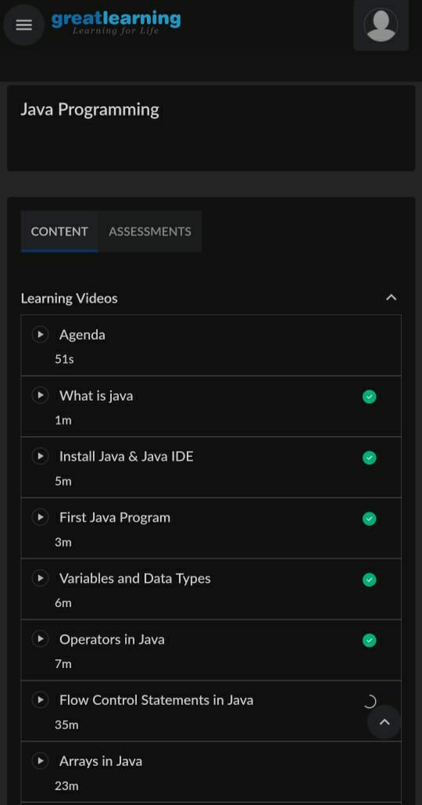

Coding Challenges Details:

1) Using methods charAt() & length() of String class, write a program to print the

frequency of each character in a string.

“Hello friend”

Output should be

-: 1

d: 1

e: 2

f: 1

(continued for all character in the string)

package pk;

import java.util.Scanner;

public class StringOperators

{

public static void main(String args[])

{

int i;

String str;

int counter[] = new int[256];

Scanner in = new Scanner(System.in);

System.out.print("Enter a String : ");

str=in.nextLine();

for (i = 0; i < str.length(); i++)

{

counter[(int) str.charAt(i)]++;

}

// Print Frequency of characters

for (i = 0; i < 256; i++)

{

if (counter[i] != 0)

{

System.out.println((char) i + ":-" + counter[i] + " times");

}

}

}

}

2) Write down a java program to print even and odd numbers series respectively

from two threads: t1 and t2 synchronizing on a shared object

Let t1 print message “ping — >” and t2 print message “,—-pong”.

Take as command line arguments, the following inputs to the program:

Sleep Interval for thread t1

Write down a java program to print even and odd numbers series respectively from two

threads: t1 and t2 synchronizing on a shared object

Let t1 print message “ping — >” and t2 print message “,—-pong”.

Take as command line arguments, the following inputs to the program:

Sleep Interval for thread t1

Sleep Interval for thread t2

Message per cycle

No of cycles

public class PingPong extends Thread {

static StringBuilder object = new StringBuilder("");

public static void main(String[] args) throws InterruptedException

{

Thread t1 = new PingPong();

Thread t2 = new PingPong();

t1.setName("\nping");

t2.setName(" pong");

t1.start();

t2.start();

}

@override

public void run() {

working();

}

void working() {

while (true) {

synchronized (object) {

try {

System.out.print(Thread.currentThread().getName());

object.notify();

object.wait();

} catch (InterruptedException e) {

e.printStackTrace();

}

}

}

}

}